School Admission Policy 2023/24

Admission policy:

Latest consultation on this policy: | Nov 2021
Policy determined on: | March 2022
Policy determined by: | Governing Body

Admission Policy for Bardsey Primary School for admission in September 2023
The Governing Body is the Admissions Authority for Bardsey Primary. We are responsible for determining the school’s admissions arrangements including this policy and deciding who can be offered a place in accordance with the policy.

For applications in the normal admissions round (entry into Reception in September), all applications will be processed in accordance with the co-ordinated admissions scheme.

Applications should be made to your home Local Authority for a place at our school. The closing date for applications is 15 January 2023. In April, your home Local Authority will send you the offer of a place at our school on behalf of the Governors.

Headteachers or school-based staff are not authorised to offer a child a place for Reception for September entry.

The Governing Body makes the offer of places in all other year groups and for entry to Reception outside the normal admissions round.

Published Admission Number for reception

30 places will be available at Bardsey School for entry in Reception in September 2023.

Where there are fewer applicants than places available, all applicants will be offered a place.

Where Bardsey School is the school named on a child’s Education Health and Care Plan (EHCP), the child will be admitted to the school.

Where there are more applicants than places available, places will be offered to children in the following order of priority.

Priority 1

- i) Children in public care or fostered under an arrangement made by a local authority or children previously looked after by a Local Authority (see note 1).
a)ii) children who were in state care outside of England and ceased to be so as a result of being adopted (see note 1)

- Pupils without an EHC plan but who have Special Educational Needs, or exceptional medical or mobility needs, that can only be met at a our school (see note 2).

Priority 2

Children with older brothers or sisters who will be attending our school at the start of the academic year and are living at the same address (see note 3).

Priority 3

We will give priority to applicants who live in the defined catchment priority area for the school. The maps showing the defined catchment priority area for Bardsey school is shown at the end of the policy as Appendix 1.

You can apply for any school but if you live in our catchment area it means your application will receive a higher priority at our school than applicants who live outside the catchment area.

Living in the catchment area does not guarantee a place at the school. Priority 4
All other applicants

Tie Break

If we have more applications meeting one of these priorities than there are places available, we will offer places in order of distance from the school – so those living closer to the school would be offered a place before those living further away, when measured in a straight line. (see note 4).

In the unlikely event there are insufficient places for two (or more) pupils living in the same building (e.g. flats) or otherwise equidistant from the school, then any final place will be allocated by the drawing of lots, witnessed by an independent person.

The drawing of lots for random allocation will not be applied to multiple birth siblings (twins and triplets etc.) from the same family where they are tied for the final place. We will admit them all, exceeding the PAN where necessary. .

Note 1
A “looked after child” is defined as a child who, at the time of making the application is:
- in the care of a local authority, or
- being provided with accommodation by a local authority in the exercise of their social services functions (see the definition in Section 22(1) of the Children Act 1989)
A “previously looked after child” is defined as a child:
- who was previously looked after but ceased to be so because they were adopted or became subject to a Special Guardianship order or a Child Arrangements order, or
- who has been in state care outside of England and ceased to be so as a result of being adopted

If you are making an application under the priority for a previously looked after child, you will need to complete and send to Leeds City Council Admission Team a Priority 1a Supplementary Information Form and a copy of the court order so the LA can verify this priority. A copy is attached to this policy in appendix 2 and the form can also be downloaded at www.leeds.gov.uk/admissions

Note 2

The priority will be given to children based on their exceptional medical or social needs.

‘Social need’ does not include a parent’s wish that a child attends the school because of a child’s aptitude or ability or because their friends attend the school. ‘Medical need’ does not include mild medical conditions as all Leeds schools are expected to be able to meet these needs.

Each application must include evidence, from a medical specialist or social worker of the child’s need and why they must attend this school rather than any other, based on those needs. This evidence must be submitted by a written request addressed to the Chair of
Governors. If evidence is not submitted to the school with the application, a child’s medical or social needs cannot be considered.

Note 3

For these purposes, brothers and sisters must be living at the same address as the applicant child. Siblings refers to brother or sister, half brother or sister, adopted brother or sister, step brother or sister, foster brother or sister. The definition does not include cousins or other family members sharing a house.

Note 4

A straight-line measurement of distance is used as provided by Leeds City Council admission team. Geographic Information System (GIS) mapping is used in the school admission system. The program measures the ‘straight-line’ distance from a defined point on the main school building to your home address. The point measured to at your home address is determined by the Local Land and Property Gazzetteer (LLPG), which provides coordinates for every dwelling. If it is not possible to match your address in the LLPG then we will use a manually identified point at the centre of your dwelling.

Note 5 - Catchment priority areas

Bardsey Primary School has a defined catchment area which is attached at the end of this policy as appendix 1.

You can apply for any school but if you live in our catchment area it means your application will receive a higher priority at our school than applicants who live outside the catchment area.

Living in the catchment area does not guarantee a place at the school. Address
For admission purposes, the home address is the child’s permanent address, where the child usually lives with their parent or carer.

You must not use any other address on your application, including using the address of a childminder or relative or renting a property for a short period of time as this could be considered as using a fraudulent address. We will investigate any queries about addresses and, depending on what we find, the school place offer could be withdrawn.

Only one address can be used on your application for a school place. Where shared care arrangements are in place, both parents must agree which address will be used on the application, and this should be the address where the child lives for the majority of the school week. If no joint declaration is received by the closing date for applications, the local authority will determine which address will be used, based on where the child spends the majority of the school week. In instances where the child spends equal time with each parent, the home address will be taken as the address where the child is registered with the doctor.

When we make an offer, we assume your address will be the same when you take up the school place in September. If you plan to move house, you must still use your current address on your application. As soon as you move house, you must tell us your new address, providing proof of your house move (including evidence of entry to the new address and exit from the old address) as this may mean we have to change the school place offer.

If it is found that an intentionally misleading or false address has been given with the aim of fraudulently securing a school place, that place may be withdrawn even if the child has already started at the school.

Parental Disputes

Parental Responsibility gives both parents important legal rights and responsibilities including involvement in decisions about which schools to preference. Both parents should agree the details of the applications, including the address to be used, which schools to be applied for and which parent submits the application. Where we receive two conflicting applications, we will need to obtain written evidence that all those with parental responsibility agree the application or a Court Order specifying who should apply. Until we receive this relevant evidence, we will be unable to process the application further and places may have to be offered to other applicants.

Late Applications

If you return the preference form after the deadline (15th January) we cannot guarantee to consider your preferences at the same time as those received on time.

Late applications will be administered in accordance with the Leeds City Council Co-ordinated scheme and we will adopt any late date they use.

Accepting Offers

Parents will be asked to accept the offer of a place directly with our school. This will not affect your position on any waiting list for a higher preference, or the right to appeal. Parents who do not wish to accept the offer, or do not accept the offer within a reasonable time, may have the place withdrawn. This may leave your child without a school place.

Waiting List

After offers have been made on offer day in April, parents can ask to go on the waiting list for our school. Waiting lists will also be held for each year group for applications outside of the admissions round.

All waiting lists will be held in criteria order of the admission policy and will close at the end of the academic year (July 2024). Each time a child is added, the list is ranked again in line with the published oversubscription criteria in this policy.

Under the Admissions Code, looked after children, previously looked after children, and those allocated a place at the school in accordance with a Fair Access Protocol must take precedence over those on a waiting list.

Please be aware that if your child is placed on a waiting list after offer day and a place becomes available at a higher preference school before the end of August 2023, your child will automatically be allocated the place at your higher preference school by the Council. This will automatically withdraw the place at a lower preference school, and this may then be allocated to another child.

Temporary School Site

If a school has to move to a temporary site for any reason, such as the building being damaged by a fire, distance measurements will be based on the school’s permanent site.

Starting Reception Age

Children are expected to start primary school in the September following their 4th birthday. Parents must ensure their child receives an appropriate full time education from the term following their fifth birthday. Parents can request that the start date for their child is delayed until later in the school year in the case of children who have not yet reached their 5th birthday, however where a place has been offered, this must be taken up by the beginning of the term after the child’s 5th birthday, or at the latest, the start of term after the Easter break.
You can also request that your child attends part-time until he/she reaches compulsory school age. You should discuss delayed or part-time attendance with the school.

Admission out of chronological age (including deferment for summer born children)

A request may be made for a child to be admitted outside of their normal age group, for example if the child is gifted and talented or has experienced problems such as ill health. In addition, the parents of a summer born child (a child born between 1st April and 31st August) may request that the child be admitted out of their normal age group, to reception rather than year 1.

Parents should apply in the normal admission round and also submit a written request addressed to the Chair of Governors specifying why admission out of normal year group is being requested and the year group in which they wish their child to be allocated a place.

When such a request is made, the Governors/ Trust will make a decision on the basis of the circumstances of the case and in the best interests of the child concerned, taking into account the views of the headteacher and any supporting evidence provided by the parent.

There is no right of appeal against a decision relating to admission out of chronological age.

Applications outside the normal admission round (in- year applications)

All applications outside the normal admission round should be made using an in year application form (ICPF) which is available from Leeds City Council.

The application should be made to Leeds City Council Admissions team who will then notify our school about the application. Our school will contact you directly to confirm whether we can offer a place. If our school is full you will be offered a right of appeal and will be added to the waiting list.

Where a vacancy arises, places will be offered based on the published oversubscription criteria within this policy.

Where no house move has taken place, you will be offered a place to start at the beginning of the next term, unless no other accessible school place is available to you.

You can find out about vacancies in schools on www.leeds.gov.uk.

Appeals

If you apply for a place at our school and an offer cannot be made, you have the right to appeal against the refusal to an independent appeal panel constituted and operated in accordance with the School Admission Appeals Code.

Appeals in the normal admission round –
Leeds City Council has an appeals timetable containing deadlines and timescales which can be found at School appeals (leeds.gov.uk) Appeals will be heard within 40 school days of the appeal request being received.

Appeals against a decision for a transfer of school place, outside the normal admission round, can be submitted any time during the academic year. Appeals will be heard within 30 school days of the appeal request being received (where the in-year application has been processed and the right of appeal has been issued).

Fair Access Protocol

All schools have an active role in admitting pupils under the Fair Access Protocol. The protocol operates outside the boundaries of the Admissions policy. It is a statutory requirement and the Protocol apples to all Leeds schools. The aim is to make sure the most vulnerable children are offered a place at a suitable school as quickly as possible, and that no school, including those with places, is asked to take a disproportionate number of vulnerable children. Leeds City Council’s Fair Access protocol can be found at www.leeds.gov.uk

Appendix 1 - Catchment map

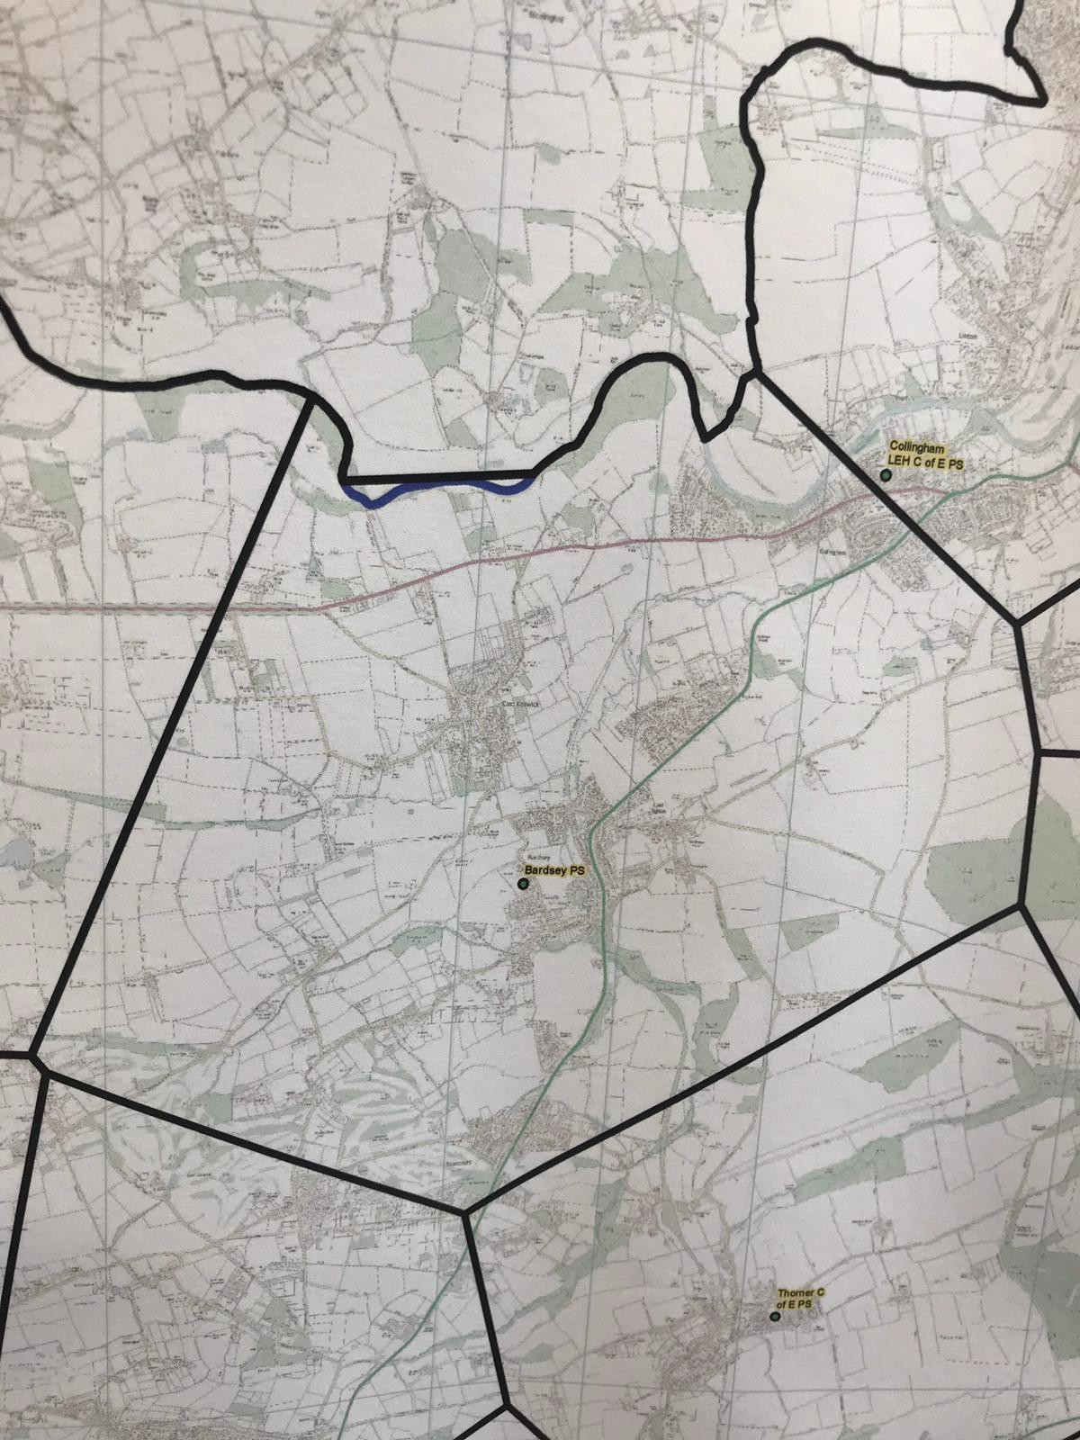

The School Admission Code (2014) gives priority admission to children who were previously looked after by a Local Authority but have left care through an Adoption Order, Special Guardianship Order or Child Arrangements Order. To claim this priority, please answer the following questions:
Which Local Authority (or state if you child was adopted from care outside of England) cared for the child immediately before the order was made:
…………………………………………………………………………………………
Which court order do you hold for the child:
Adoption Order Special Guardianship Order Child Arrangements Order
Please attach a copy of this order to the form - you can delete sensitive information (for example the name of the birth parents) if you wish to do so. The fact you have applied for admission under this priority will be known to the school. The court order will not be stored against your child’s records.

To be completed when requesting priority admission for a previously looked after child.
Appendix 2
School Admissions Priority 1a Supplementary Information Form

Please do not complete this form if the child is currently looked after by the Local Authority – the social worker should complete the online application
Year group applied for:
(eg Reception, Yr 7, Yr 4)
CHILD DETAILS

Surname: |  |  | Forename(s):
Fornames(s | )
Date of Bir | th:
Address:
Postcode:

PRIVACY NOTICE

Leeds City Council takes its obligations under the Data Protection legislation very seriously. The Admissions team collect information from you to assess your child’s eligibility for a school place. We collect your personal information in respect of admissions and appeals which is considered against the Council’s and school’s policies for admissions. Our service also needs to use sensitive personal data relating to you (also called “special category data”) such as religion and ethnic origin information in order to provide equality of opportunity or treatment.

Leeds City Council is the Data Controller for your information and our legal basis for processing the data is under a legal obligation where it is personal data (such as the School Admissions Regulations 2012 and the School Admissions Code 2014), and where we are processing special category information, under our obligations of substantial public interest. The data collected is required to ensure all children have a school place suitable to their age, ability and needs. Leeds City Council work to ensure that places are allocated and offered in a fair, transparent and open way.

In processing your application we will share information with services within the Council and also with other relevant organisations such as schools, NHS and the Police etc. We will also give some information about you to relevant government departments, such as the Department for Education etc, for statutory reporting purposes and in order to make the services of Leeds better. There may be circumstances where we need to use and share your information without your agreement, however this will only occur where we are legally required to do so.

Your personal data will be retained up to your child’s 25th birthday after which it will be confidentially destroyed. Any school admission appeal papers held by the Council in respect of schools who conduct their own appeals will be held by the Council for 2 years and will be destroyed after this period.

You have rights in respect of the information we hold about you, including the right to ask for access to your information or to withdraw from this process. Objecting to Leeds City Council using your information in this way, would restrict the Council’s assessment in giving proper consideration to your application and can result in the inability of schools offering a place/withdrawal of a place. Further information is available at https://www.leeds.gov.uk/opendata/your-rights. To exercise any of your rights, please contact: dpfoi@leeds.gov.uk; or send to Information Management & Governance, PO Box 837, LS1 9PZ, and we will advise you of the procedure.

Further information about how we process your information can be found on the Council’s privacy notice including contact information for the Council’s Data Protection Officer: https://www.leeds.gov.uk/privacy-statement/privacy- notice. A paper copy of this information is available on request.

*PARENTS/CARERS SIGNATURE REQUIRED*

Signed………………………………………………………..Date………………………………

Please return this form by email to: startingprimary@leeds.gov.uk

Or by post:
Leeds City Council PO Box 837 School Admissions Leeds LS1 9PZ
Checklist
□
□
□
Have you answered all the questions? Attached a copy of the court order?
Signed and dated the form

